**High Risk Substance Use Screening: Generic logic algorithm**

Criteria: Paid sex work, multiple partners, MSM, high prevalence, known exposure, sexual violence

Does the patient identify as high risk for infectious disease based on sexual activity?

***False***

***True***

Initiate low risk screening protocol

Look for presence of recent testing: use criteria for specific condition

***False***

***Absent***

***Present***

Initiate screening protocol

What was the result of test?

***Positive***

***Negative***

Update reminder for screening to the end of the screening interval

Screening not indicated—initiate disease management

**High Risk Substance Use Screening: Generic logic algorithm**

Criteria: IVDU+

Does the patient identify as high risk for infectious disease based on substance abuse?

***False***

***True***

Initiate low risk screening protocol

Look for presence of recent testing: use criteria for specific condition

***False***

***False***

***True***

Initiate screening protocol

What was the result of test?

***Positive***

***Negative***

Update reminder for screening to the end of the screening interval

Screening not indicated—initiate disease management

**Low Risk Screening: Generic logic algorithm**

Criteria: disease specific

Does the low risk patient require screening?

***False***

***True***

***False***

Is the patient eligible for vaccination?

Look for presence of recent testing: use criteria for specific condition

***False***

***True***

***False***

***True***

Order vaccination

Initiate screening protocol

What was the result of test?

***Negative***

***Positive***

Update reminder for screening to the end of the screening interval

Screening not indicated—initiate disease management

**Hepatitis B Screening: Screening Protocol**

Risk group meeting criteria for chronic hepatitis B virus (HBV) screening?1

***True***

Order screen for HBV infection with HBsAg, anti-HBs, and anti-HBc (total or IgG)1

***True***

HBsAg(+)

***True***

***False***

Add Hepatitis B diagnosis, report to public health surveillance, add to HBV registry, trigger HepB care protocol

Anti-HBs (+)

***False***

Anti-HBc (+)

Order for HepB vaccination

***True***

***True***

Immune to HBV: turn off HBV screening and vaccine reminders

Prior HBV infection: Update History

HepB vaccination given?

***True***

***False***

Create reminder for first dose

Create reminder for next dose

Table of risk groups for HBV

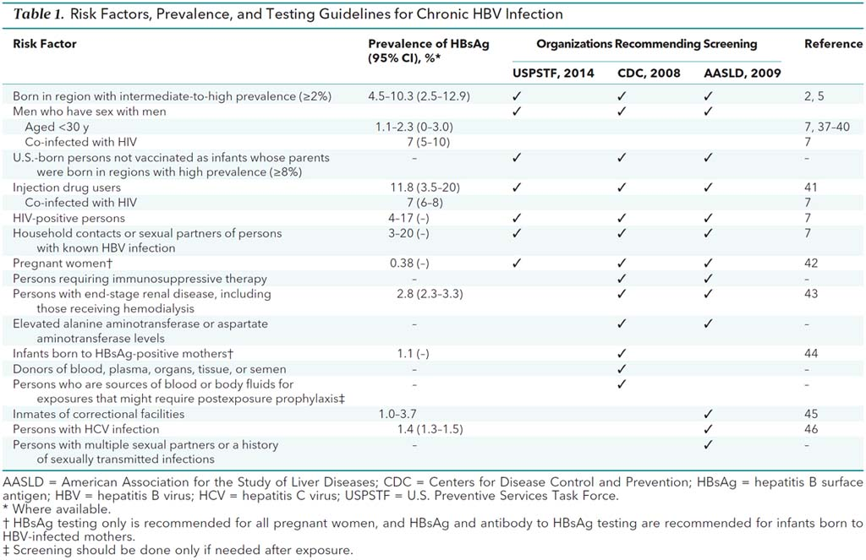

**HIV Screening: Screening Protocol**

Criteria: Patient or partner with: IVDU+, sex work (money or drugs), STD+, MSM, multiple partners, new partner OR blood/fluid exposure, TB+ or STD clinic encounter

***False***

Risk group meeting criteria for HIV screening?

***True***

HIV Prevalence <0.1%?

***True***

Patient Opt Out: document and reset reminder?

***False***

Turn off reminder

Patient provided informed consent (verbal or written)?

***False***

***True***

Document provider consent provided (yes/no), Order screen for HIV RNA

***True***

HIV+

***True***

***False***

Add HIV diagnosis, report to public health surveillance, add to HIV registry, trigger HIV care protocol

Candidate for PrEP?

***False***

***True***

Counsel prevention, reset screening reminder

Initiate PrEP protocol